**Mastering Active Listening in the Workplace**

WBT comm_43_a04_bs_enus

Success in the most difficult professional conversations can depend on the creative deployment of active listening skills. There are critical moments in our professional lives where the active listening toolkit can make the difference between excellence and failure. Whether it be addressing the angry client, emotional subordinate, evasive witness, or hesitant buyer, effective listening can be the foundation of how you navigate and control the conversation, and achieve the results you desire. Excellent and persuasive communicators employ a creative blend of the skills tailored to each unique situation. In this course, you'll review the skills and techniques for mastering active listening. You'll learn to trust the process, engage evasive speakers, effectively steer emotionally charged conversations, and apply active listening within sales and negotiation scenarios.

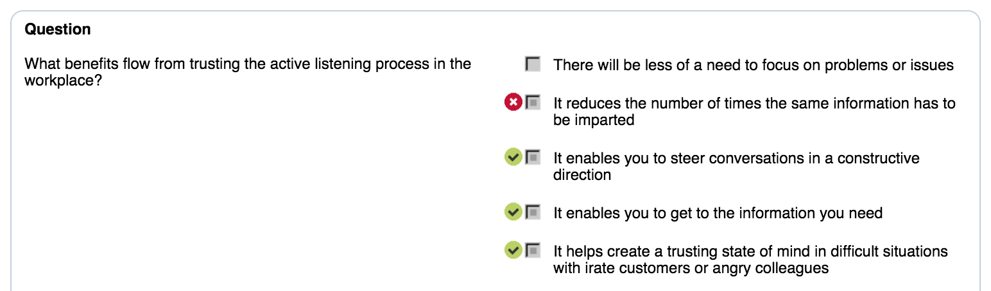

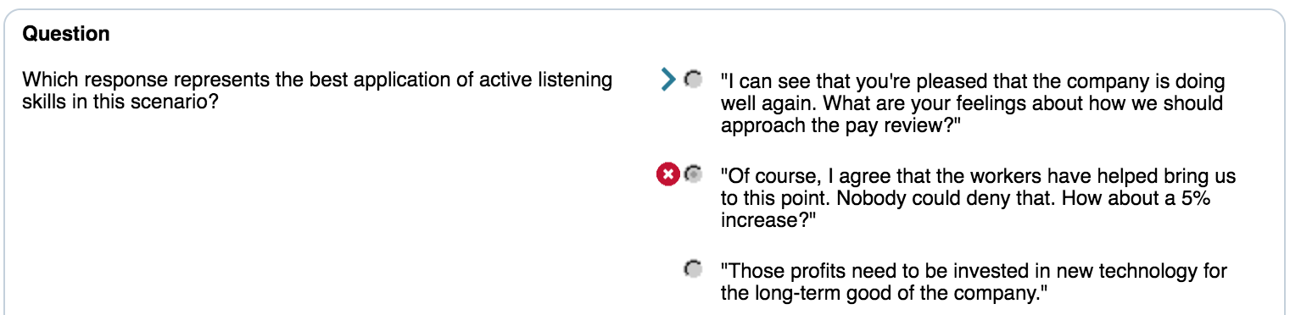

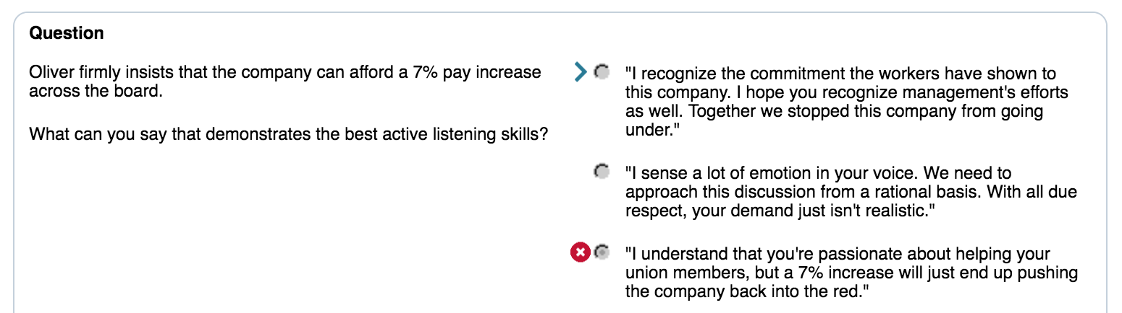

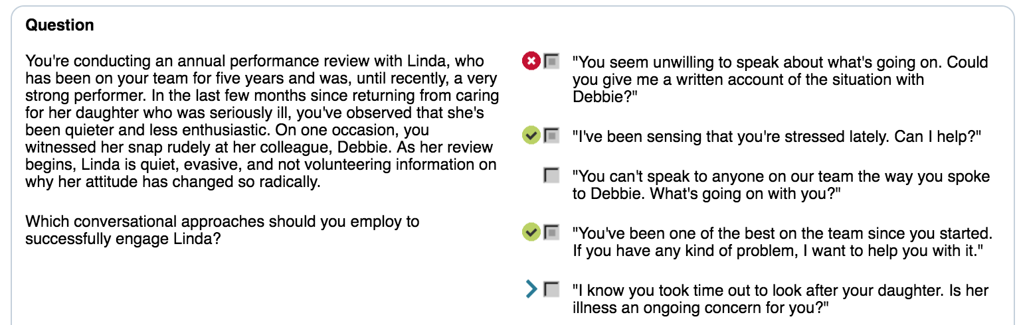

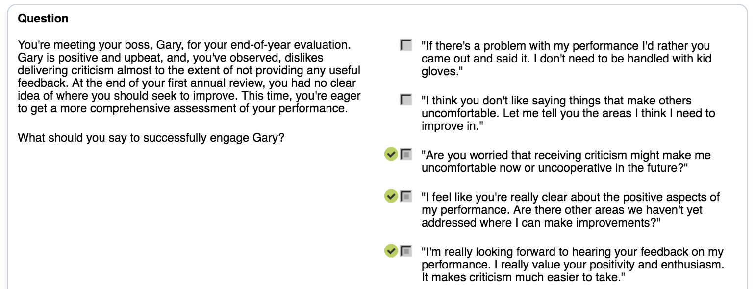

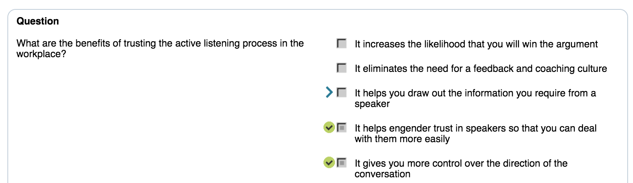

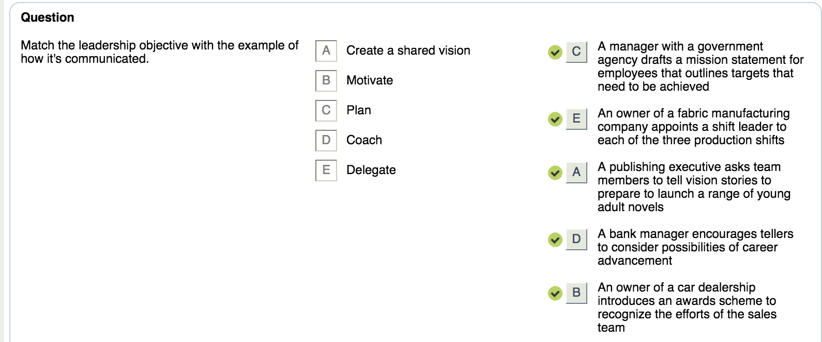

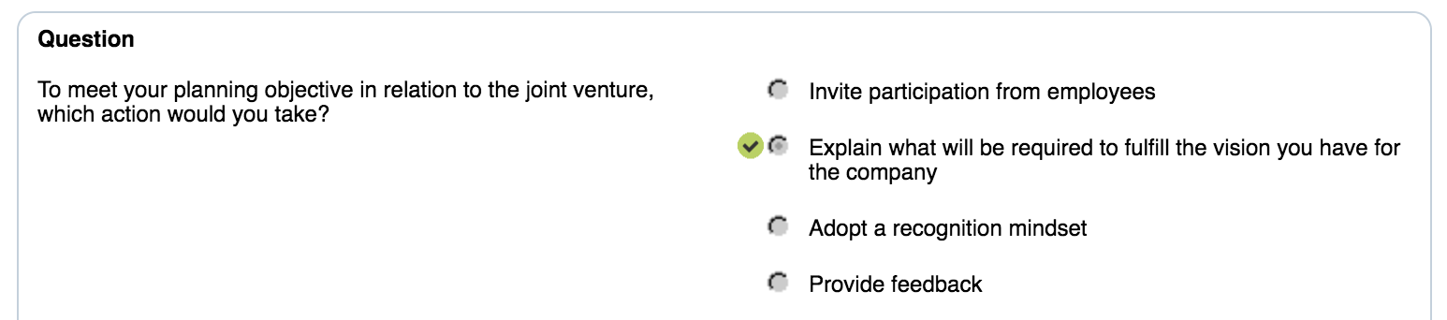

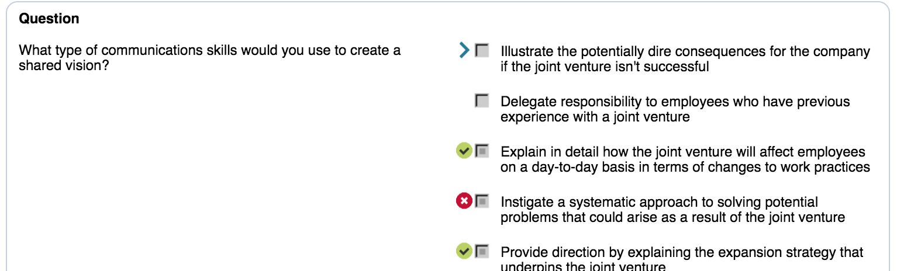

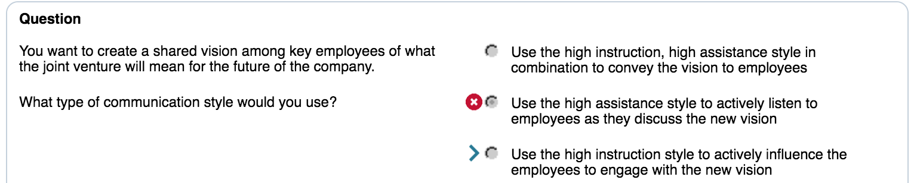

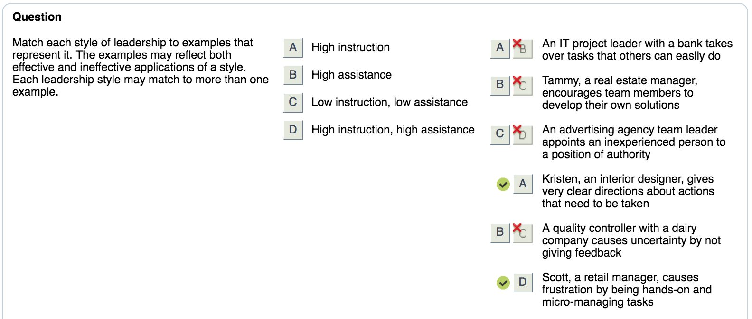

Active deployment of listening skills will help to influence behavior

**Trust active listening**

Avoid taking action or jumping in to make your point simply because your mind wants to.

Don’t confuse saying what you want with getting what you want

**Adapt the skills**

**Achieve listening fluency**

**Evasive speaker**

Establish trust and unconditional positive regard

Draw out thoughts and emotions

* Emotional labeling
* Minimal encourager
* Search for the intent behind their evasion

Self control

* Control your emotions
* Emotional motivators like pride, ambition, and dedication
  + Assess the situation
  + Rational thinkers show goal oriented with realistic and tangible requests and purposeful behavior and comments
  + Emotional thinkers show goals that are less clear or have an emotional source, their behavior is less disciplined and more expressive (who provokes)
  + Speak at a pace and toner slower
  + Build empathy – see things from other side of the desk
  + Agree where possible or acknowledge a point
  + Tangible demands Vs emotional needs

Best practices

* Actively listen and take your time. Don’t try going for resolution too early
* Steer the conversation and less on open ended prompts
* Satisfy each side’s needs
* Verbalize a commitment for a solution that’s best for all
* Acknowledge their point or their perspective
* Find common ground
* Demonstrate care and positive regard for the speaker
* Extract as much as possible

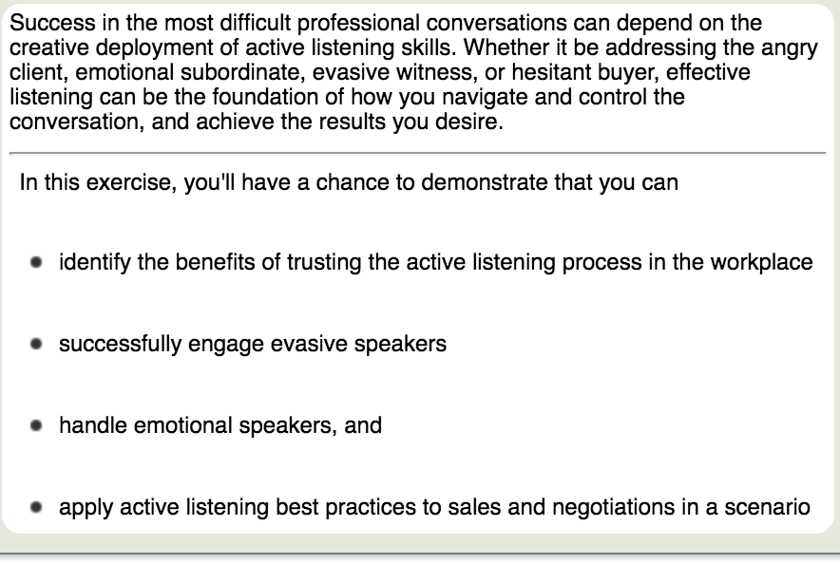

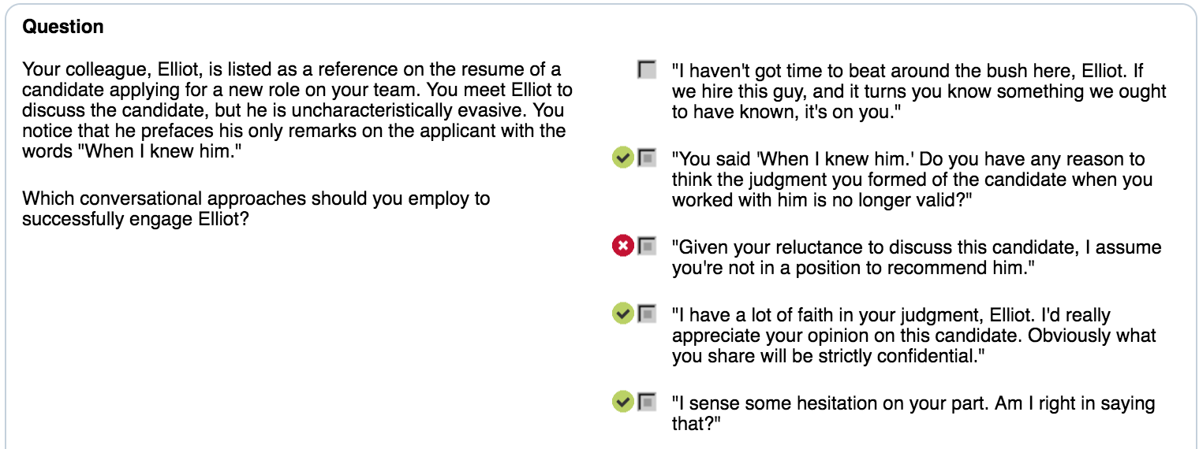

Motivators

* Accomplishment
* Control
* Security
* Dignity
* Relationships

